**Change Management Plan:**

A change may occur at any point during the project. For instance, a change in the requirement, a change in the design or interface. Such changes need to be managed in an efficient manner. Change management is the process, tools and techniques used to manage changes to achieve the required business outcome. Change management involves steps like Planning the change, managing the change and finally reinforcing the change. The tools that can be used include individual change model, communications, sponsorships, coaching, training. Our company Desired Solutions has a Change Management Process (managed in ServiceNow Platform) in place to handle changes in any project. A change request is raised by a team member the CR is currently in Draft state, this change request is then reviewed and modified if needed by the team lead and sent to the Change Management Team. The Change Management Team reviews the CR to see if any more details are needed (if yes, the Change Request Team will not reject and send it back to the team that submitted the Change Request) if not, they approve it. The change management team can also reject the request, in this case the change management process stops. After this approval, the change management team assigns a task to the teams that will be impacted by this change. Each team member completes the task, after which Documents are updated and communication is sent to all the stakeholders.

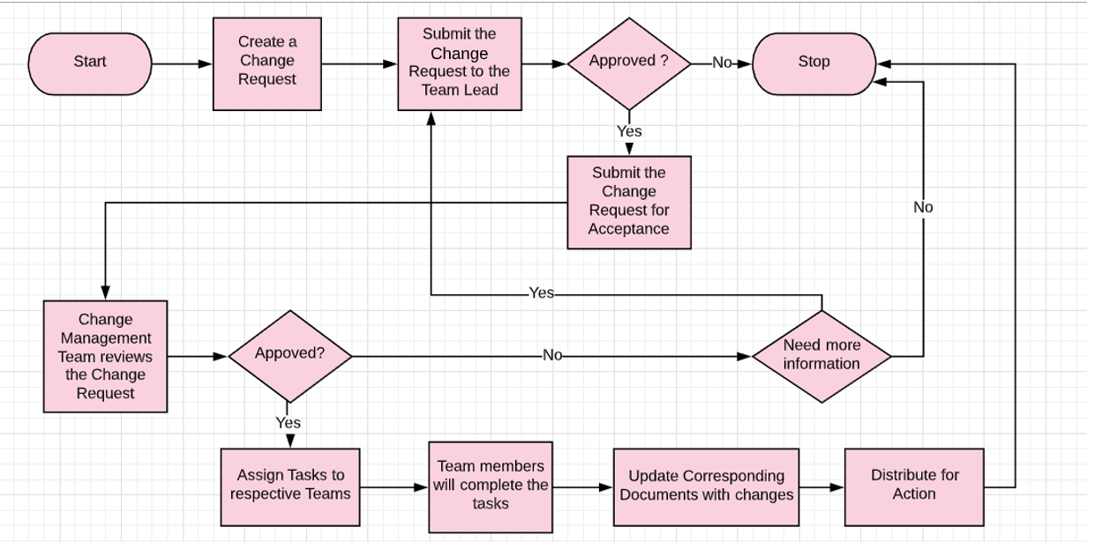

|  |  |  |
| --- | --- | --- |
| Sr No | Flowchart Element | Description |
| 1 | Start | Whenever a change originates this process of Change Management Plan will start from this point. |
| 2 | Create a Change Request | Any member from different teams in the project can raise a change request. For example, a developer or a tester. |
| 3 | Submit the Change Request to Team Lead | This change request is then submitted to the team lead of that team to review and modify to the change request. |
| 4 | Approved? | The team lead decides whether the change request can be submitted to Change Management team and he can also make changes to the request and approve it and submit it for Acceptance (Change Request is now in Pending Review state). If not, the team lead will reject and change request and the process terminates.  **Note: If the Change Requestor is Team Lead this step will skip.** |
| 5 | Submit the Change Request for Acceptance | The Change Request will now be submitted to the Change Management Team. |
| 6 | Change Management Team Reviews the Change Request | The Change Management Team reviews the change request, they will then decide to approve or reject. |
| 7 | Approved? | If Change Management team does not approve the change request again goes to step Draft state. If they approve Change Request goes to Work in Progress State) |
| 8 | Need more information? | If the change management team rejects the Change Request, the process will stop. If not, the change management team can send the Change request back to the team who submitted the change request for necessary modifications in the Change Request. |
| 9 | Assign Task to respective Team | Based on the change request inputs, task is assigned to respective team |
| 10 | Team members will complete the task | Assigned Team member performs the task and closes the task. |
| 11 | Update corresponding documents with changes | Necessary updates are made to the respective documents. |
| 12 | Distribute the action | Communication is sent to all the stakeholders about the change being implemented. |
| 13 | Stop | The Change Management Process has finished |